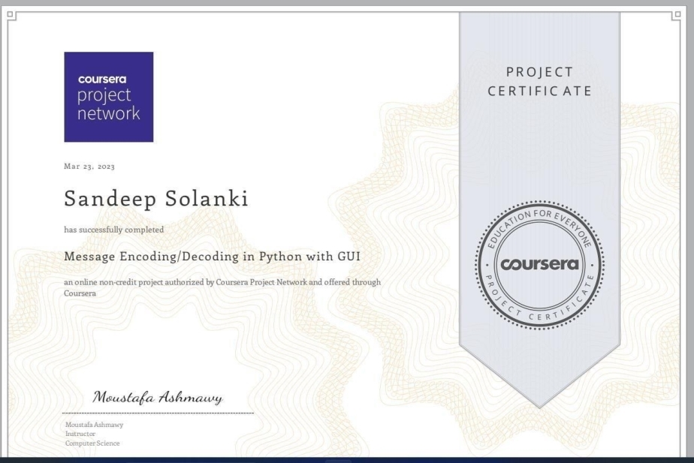**Certification** **of** **guided** **project** **SANDEEPSOLANKI (2101330100200)**

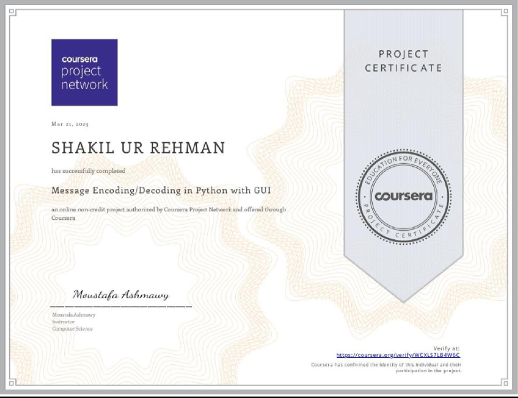**SHAKIL UR REHMAN (2101330100205)**

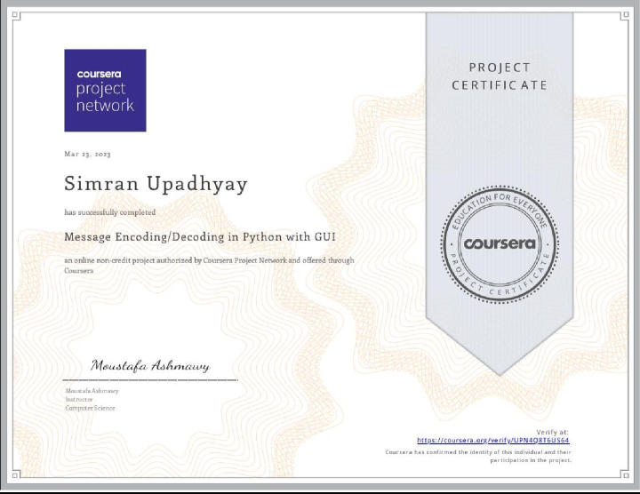**SIMRAN UPADHYAY(2101330100222)**